CHAPTER 10B: Byzantine Christendom (p. 415-424)

Textbook Divide and Conquer
Directions: Using your notes and the textbook, organize a response for your group’s assigned question. Type up response using google docs and email/share your answer with Mr. Tickler. Your response should include a 2-3 sentence claim that directly answers the assigned prompt. In addition, you must include key details and facts that would support and explain your claim. Your group must decide how best to organize that additional evidence list (ex. bullet point list, use of bold headings to denote themes or categorical connections, graphic organizer or chart to group information, etc.) Class responses will be posted to the class website and each group will present their information to the class.
- Characterize the structure of the Byzantine Empire. (Grace A)
The Byzantine Empire controlled a large region which allowed for the controlling of trade routes throughout southeastern Europe and the Mediterranean which was obtained through Emperor Justinian’s conquest. He grew his army by using the peasants to extend the borders and control more of the land which allowed for the trading of ideas and led to economic prosperity. The social hierarchy practiced by the Byzantine Empire was a mirror of the former Roman Empire’s. The political structure changed from the Roman by implementing a monarchy rather than using democratic ideas.

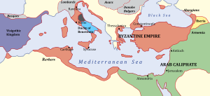
- The geographic location of the Byzantine Empire allowed for dominion over the Red Sea and the Black Sea in southeastern Europe. At the height of the Empire during Emperor Justinian’s rule, the Byzantine Empire gained complete control over the Mediterranean. Located in the middle of the Bosphorus, Black Sea and the Mediterranean sea resulted in forced trafficking of trade from North Africa, Asia and Europe. The control of the major sea routes through the Mediterranean forced merchants in the Atlantic that wished to trade with the rest of the Middle East and Islamic states to pass through. This led to the Byzantine Empire’s influx in economic prosperity through taxes.

- Until about 1200, the Byzantine empire remained a major force in the eastern Mediterranean due to the control of Greece, Southeastern Europe, and Anatolia. Political authority was tightly centralized in Constantinople where the emperor ruled and governed as “God’s worldly representative,” and as the “peer of the Apostles.” The emperor also considered himself as the “sole ruler of the world” which he believed to give him dominion over everything. Also, an imperial court was set into motion that imitated the ancient Persian imperial splendor. High officials were trained in Greek rhetoric and literature. However, the centralized state had little impacts on most people’s lives and only affected through taxes, order, and the suppression of revolts. This was upheld until the collapse of the Empire in 1453.
- Military arose from appointed generals and their civil authority to raise armies from landowning peasants. It established a “territorial base [that] the empire’s naval and merchant vessels were active” in to allow for a powerful army. The Emperor Justinian managed to use the army to its fullest extent by conquering the land once claimed and controlled by the previous Roman Empire allowing for an age of prosperity. Although he acquired new lands and brought an influx of trade and the spread of ideas through the region, he also exposed his armies to more threats and was forced to thin his armies to maintain all the land. This caused him to rely on a weakened army to defend foreign

- List the causes of the decline of the Byzantine Empire. (Jordan B)
The Byzantine Empire portrayed a variety of strengths, but its weaknesses contributed to its fall. The Byzantine Empire fell due to a multitude of differences between the different types of interpretation of Christianity, weak military and difficulty to govern all of its land.

In the beginning of The Byzantine empire, they had great wealth which allowed it to sustain itself for warfare. As the Empire was bombarded by Roman Catholic crusaders and others, they managed to endure themselves while experiencing some bumps in the road. Despite this, the split of Eastern and Western Europe, divided by its different interpretations of Christianity, created conflict among the different groups. Violence among the people created instability within the Empire because, without the people that make up the Empire, there is no Empire to start with. The matter of the many disputes created debates for what was considered the “right,” way of practicing and interpreting Christianity.

The event of “The Great Schism,” is where representatives from each side excommunicated each other, claiming that the others were unsound for their interpretation. This resulted in divisions among the people- leading to different military troops to defend their group. Not to mention that geographically, it was made difficult to control all the parts of the empire.

Its large, sectionalized and ununified civilization made it difficult to govern and maintain all of its land. The Empires experienced many invasions, weakening its war defense. For example, the 4 Crusades, which contributed to the split of East and West. The Romans stole from Constantinople and held the city for many decades, thus weakening its army.

- Identify the differences between Eastern Orthodox Christianity and Roman Catholicism. (Max G)
Claim: Eastern Orthodox Christianity and Roman Catholicism were different in many aspects including their political authority, culture, and religious beliefs. The two churches had different structures of political authority, different cultures, and has some differences in their religious beliefs.

Differences between Eastern Orthodox Christianity and Roman Catholicism
Eastern Orthodox Christianity | Roman Catholicism
- It had a pervasive influence on every aspect of Byzantine life  - Latin was abandoned in the Byzantine Empire in favor of Greek  - Eastern Orthodox leaders sharply rejected the growing claims of Roman popes to be the sole and final authority for all Christians everywhere  - Eastern Orthodoxy, official name Orthodox Catholic Church, one of the three major doctrinal and jurisdictional groups of Christianity  - Does not believe in purgatory and indulgences  - View on religion was more theoretical | - Latin remained the language of the Church and of elite communication  - Roman Catholicism, Christian church that has been the decisive spiritual force in the history of Western Europe  - The Roman Catholic Church traces its history to Jesus Christ and the Apostles  - The Pope is supreme and has immediate jurisdiction for every church in the world  - Has a strict hierarchy under the Pope  - Religion of the Western Roman Empire, fell before Eastern Rome.  - View on religion was more practical
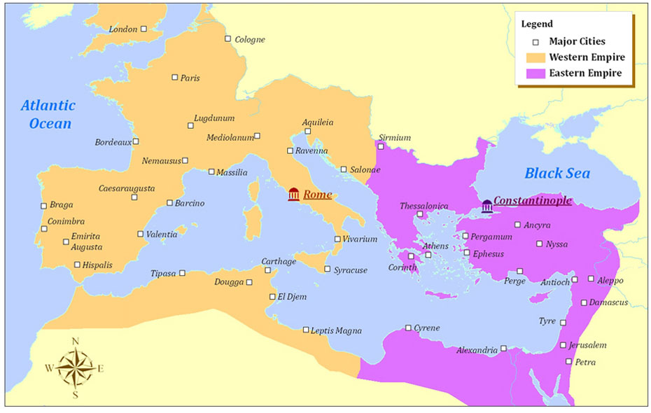

- Explain the causes of the split with the Christian Church into Latin (Roman) Christianity and Eastern (Orthodox) Christianity in the eleventh century. (Kiery L)
The split of the Christian Church between Latin Christianity and Eastern Christianity in the eleventh century was caused by many differences and misunderstandings.They differed in their theology and church practices. This started in 1054 when the representatives of both churches declared that those of opposing traditions were not true Christians and after this they experienced constant conflict.

- Differences in theology and church practice
- Byzantine prohibited the use of icons, popular painting of saints and biblical scenes
- Priests in the West shaved and were supposed to remain celibate
- The priests in Byzantium allowed their beards to grow and were allowed to marry
- Arius, an Egyptian priest, held that Jesus was created by God rather than living eternally with him
- Orthodox: used bread leavened with yeast in the Communion
- Roman: used unleavened bread in the Communion
- Disagreements about the nature of the Trinity, the source of the Holy Spirit, the original sin, and relative importance of faith and reason- created a lot of controversy
- Differences in language
- Roman: Latin
- Orthodox: Greek
- Eastern Orthodox Christianity had a persuasive influence on every aspect of Byzantine life
- Believed that the empire and the Church were equally essential to achieving eternal salvation
- Believed in divine rulers which provided a cultural identity for empire’s subjects

- Summarize ways in which the Byzantine Empire linked to a wider world. (Chris P)
Claim: The Byzantine Empire linked itself to a wider world through a variety political, economic, and cultural factors. For example, it’s military might was supported by “Greek Fire;” an invention that was not only adopted from the Greeks, but was then spread to other areas due to Byzantine’s exploits. This is further evidenced by the fact that their currency was widely used in the region for a long period of time. In addition to this, it was worn as a status symbol in many countries, not just that of its origin. Another example of how it was interconnected is the spread of its culture and religion. The spread of Eastern Orthodoxy and the Greek rational thinking was due both in part to their heavy economic presence in the region as well as through slow diffusion to surrounding areas. Overall, there was a multitude of examples why Byzantine was well linked with the wider historical world.

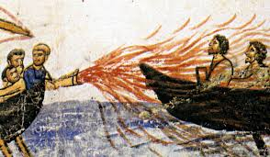
- Political and Military
  - “Greek Fire” used in conflicts with Persia
    - Flammable projectile material, invented by Greeks
    - Spread to other areas of world due to Byzantium
  - Continued long-term Roman conflict with Persia
    - Weakened both sides, leading to Persia’s downfall at hands of Arabians, as well as a considerable loss of territory from Byzantium
  - Was successful in persisting against Islam due to military feats
    - Delayed the Islamic advance into southeastern Europe for many centuries
  - Early eleventh century, military pressure brought Balkan Slavic peoples and the Bulgers under control

- Economics and Trade
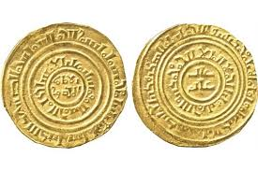
  - Central player in long-distance trade of Eurasia
    - Commercial links to Western Europe, Russia, Central Asia, the Islamic world, and China
  - Its currency (bezant) was widely used in region for 500+ years
    - Upper classes wore them as status symbols, even in countries
  - Byzantine craftsmen produced widely desired luxuries
    - Jewelry, textiles, and silk were widely desired by other countries
  - Constantinople was the center of Byzantine trade/culture, had incredible diversity

- Cultural
  - Preserved much of ancient Greek learning
  - Spread their classical heritage to China’s as well as the Islamic world
    - Stimulating impact among scientists, philosophers, theologians, and other intellectuals
  - Mixed reaction to the spread of knowledge from other countries
  - Preserved their own culture despite conflict with Islam
  - Byzantine religious culture spread among Slavic-speaking people in the Balkans and Russia

- Describe the factors that gave rise to the Russian state Kievan Rus. (Madison B)
Claim: (kendall) Through growing communication due to increased trade networks, the Russian state of Kievan Rus was able to form from a spread of ideas. Cultural diffusion and other influences from the Byzantine empire, especially those of the Eastern Orthodox Christianity, were able to come into contact with the rising state which had a need for unification. By the end of the 10th century, the previously isolated region of Russia was transformed into the formal state of the Kievan Rus, strongly linking the new civilization to the Byzantine Empire and at the same time establishing a sense of Russian independence and development

Economic: (Elia) With increased trade and communication, along the Dnieper River, the City of Kiev was able to become prosperous and have increased contact with the outside world such as the Byzantine empire and become cultural influenced. The prince, Vladimir had been searching for a way to unify the region and remain a prosperous state; Eastern Orthodox Christianity was the result. (city of Kiev highlighted bc its a starting point in the Russian state)

Culture: (Madison) Kievan Rus was only able to form through the followers of other major religions. The Russian State adopted very similar traditions to the Byzantine empire such as seen with their architecture, alphabet and iron use. One of the major key points to the success of the State was their adaptation and adoption of Eastern Orthodox Christianity which allowed to further unify the diverse people under one common ideology while still creating an independent culture after the collapse of the Byzantine. Through this more structured way of life, more people could easily align themselves with the rising State. (Kievan Rus highlighted bc its a key name, Eastern Orthodox Christianity highlighted bc its the specific fragmented part of Christianity that the Russians adopted)

Political: (Gaby) Both religion and culture made a home for themselves in the politics of Kievan Rus as shown by their adoption of imperial Church power in politics. Due to the close relationship of religion and politics, it enabled leaders to more easily direct the people and lead them. As seen with the Russification when it was seen the State was growing stronger due to the complete unity and pride of religion and politics conjoined.

Social: (Emily)The rise of the Russian State started with the spread of Eastern Orthodox Christian which started and was revered by the upperclassmen and those with power then slowly made its way to the lower classes. As well as the further reinforcement of accepting this new religion by building churches among sacred spots of pagan worshippers and creating a social hierarchy in which religious leaders would be on top.

