CHAPTER 10B: Byzantine Christendom (p. 415-424)

Textbook Divide and Conquer
Directions: Using your notes and the textbook, organize a response for your group’s assigned question. Type up response using google docs and email/share your answer with Mr. Tickler. Your response should include a 2-3 sentence claim that directly answers the assigned prompt. In addition, you must include key details and facts that would support and explain your claim. Your group must decide how best to organize that additional evidence list (ex. bullet point list, use of bold headings to denote themes or categorical connections, graphic organizer or chart to group information, etc.) Class responses will be posted to the class website and each group will present their information to the class.
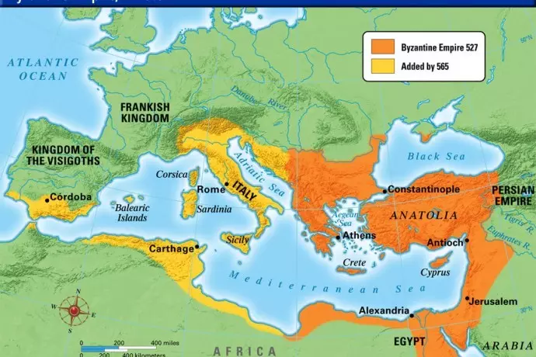
- Characterize the structure of the Byzantine Empire. (Jessie S)
Claim: The Byzantine Empire can ultimately be characterized as wealthy, developed, and militarily powerful. While it never got as large of the Roman Empire, the Byzantine Empire possessed many of the same traits as their predecessor. Their use of an Authoritarian government, relative egalitarian social structure and expansive trade systems allowed their civilization to flourish and thrive in building their empire. Many of these traits lead to various forms of political, economical and social power.

- Basics:
  - Began: 330 C. E.,
  - Location: Eastern Part of the Roman Empire; Parts of Egypt, Greece, Syria, and Anatolia
- Links to religion, Trade, Systems
  - Eastern Orthodox Church influenced the Byzantine Empire heavily
  - Constantinople was filled with churches & relics of the state
  - Rapid Arab/Islamic Expansion
  - Caesaropapism: Relationship between Church and State
- Gave “authority” by being appointed by God
  - The church was filled with religious paintings of religious icons
    - Examples: Jesus, Mary
  - The Christian Community was increasingly replaced by an awareness of difference, competition, and outright hostility
- Political Structure/Administration:
  - Autonomy
  - Wealthier, more urbanized, and more cosmopolitan than the western Roman Empire
  - Roman structures were very prominent: roads, taxation system, strong military, centralized administration, imperial court, laws, Christian Church
  - A reformed administrative system gave appointed generals civil authority allowing for armies consisting of landowning peasants within the empire.

- List the causes of the decline of the Byzantine Empire. (Natalie M)
Claim- The Byzantine Empire ultimately fell as a result of external invasion and wars. Internal problems such as regionalization which created difficulties keeping society and the military unified also heavily contributed to fall of the empire.

External Factors contributing to the fall of the Byzantine Empire -
- Arab wars caused many conflicts and began to cause trouble for the Empire
- Conflicts lasted over 300 years which led to huge loss of land and power
- The constant struggle against the Persian Empire weakened both empires allowing for the easy victory of the new Arab Empire
- The army greatly relied on locally raised troops from the different regions of the Empire. When the economy got worse and weak rulers began to appear, military power began to fall. This lead to many break-ins to the Empire such as the fourth crusade.
- The crusaders from the west shrank the size of the empire
- Defined end - Turkic Ottoman Empire took the capital (Constantinople)

Internal Factors contributing to the fall of the Byzantine Empire-
- The military system
- Empire had been divided into many regions which made it vulnerable
- Lead to locally raised troops for imperial armies
-became hard to maintain unified armies
- Civil wars / political structure
- Weak political systems lead to 2 civil wars lead by emperors grandson

- Identify the differences between Eastern Orthodox Christianity and Roman Catholicism. (Charlotte H)
Claim: While both Eastern Orthodox Christianity and Roman Catholicism ultimately had similar beliefs, they differed greatly from one another. In order to overcome geographic and cultural divisions, the Byzantine Empire unified political and religious authority under Eastern Orthodoxy and held more rigid cultural traditions and practices, thus distancing themselves from the power of Roman Catholicism.

Eastern Orthodox Christianity
- Legitimated supreme and absolute authority of the emperor
- Political authority was used in connection to orthodox christianity
- “abandoned” Latin, and used Greek language and education
- Prohibit the use of icons, popular paintings of saints and biblical scenes as used in the west
- Did allow some cultures that the West did not, such as the growth of a beard and marriage
- Orthodox rituals used items such as bread leavened with yeast

Roman Catholicism
- Political authority was kept indepent from roman catholicism
- Latin remained the language for roman catholicism
- Catholic rituals used unleavened bread for their rituals
- Free to express themselves more culturally and artistically

- Explain the causes of the split with the Christian Church into Latin (Roman) Christianity and Eastern (Orthodox) Christianity in the eleventh century. (Nicole W)
CLAIM: Although the Roman Catholics and Byzantine empire shared similarities in the fundamental teachings of Christianity, their differences in beliefs led them to diverge on to different paths. Their cultural debates of the nature of the Trinity and political struggles involving whether the Pope or Caesar should rule also contributed to their split. During the fourth crusade, however, western forces seized Constantinople and led the Byzantine Empire to rule in the next half century which mainly led to the split between the religion.

Political Power Struggle:
- didn’t agree on same leader
- eastern orthodox believed the Caesar held all authority and was the only messenger of god
- Roman Catholic believed that the Pope held all authority over the church

Social Differences:
- language barrier (Latin in West) (Greek in byzantine empire)
- In 1054, the two churches excommunicated. Opposing each other trying to come up with the true christians, having arguments.
- increasing awareness of difference, competition, and hostility

Cultural Debates:
- Caesar as the head of state. Pope as head of church (Roman Catholic)
- disagreement of the nature of the Trinity, the source of the Holy Spirit. (agree of fundamental doctrines)
- Orthodox: use of bread leavened with yeast in Communion
Catholics: unleavened bread

Trigger Event:
- During the 4th crusade, western forces seized and looted Constantinople and ruled Byzantium for the next half century.
- Unfair rule over the Orthodox Byzantines reinforced negative outlook on Roman Catholics- causing the first real split in the two churches

Differences of Byzantine rule:
- intolerance to other religions was still prominent
- prohibited icons (paintings) of Saints and biblical scenes

- Summarize ways in which the Byzantine Empire linked to a wider world. (Rachel S)
The use of powerful military force and political influence over the people along with extensive trade networks and cultural diffusion made the Byzantine Empire a center of power for the world during the Post Classical Period. The empire was constantly placing military pressure on its surrounding neighbors and they were a huge center of trade for the outside world which fostered opportunities for extensive religious and cultural diffusion.

Relationships:
- Intensive interactions with neighbors around Eurasia
- Persisting conflicts between Persian empire weakened both states
  - Became factor in success of Arab armies in seventh century, Persia eventually became part of Islamic Empire
- Byzantine resisted the Islamic world at the cost of much of its territory
  - Created “Greek Fire” which mixed oil, sulfur, and lime and it was highly flammable
  - Used as against the Arabs to fight them off
- They fought off Islam up until the Turkish Ottoman Empire (15th-16th century)
Economics:
- Central player in long-distance trade of Eurasia
- Had commercial links (meant for trade) to much of the world including:
  - Western Europe, Russia, Central Asia, the Islamic World, China
- Common currency used was the bezant, a gold coin that become common to be used throughout the Mediterranean for over 500 years
  - Wearing these coins showed high-status in less wealthy locations such as Western Europe.
- Much of their goods were in high demand.
  - This includes jewelry, gemstones, silver, gold work,linen, woolen textiles,and purple dyes.
- It’s silk industry (based on Chinese tech.) supplied all of the Mediterranean with silk.
Culture/Religion:
- Had significant cultural influence
- Transmitted ancient Greek learning to the Islamic World & Christian West
- Impact among intellectuals (scientists, philosophers, etc.)
  - Some saw it as an aid to faith & better understanding of the world
  - Others viewed it as impious & distracting
- Religious culture spread through Russian and Balkans - slavic-speaking
  - South was taken by Islam, Byzatimes looked north
- 9th century - Cyril and Methodius developed alphabet based on Greek and (kind of) Slavic languages
  - Used to translate the bible and religious literature; aided conversion
- Early 11th century - used steady military force to overtake Balkan Slavic peoples and Bulgars.
  - Brought along Christianity and literacy

- Describe the factors that gave rise to the Russian state Kievan Rus. (Bassel L)
The unification of the Kievan Rus was due in part to the convenience of Eastern Orthodox Christianity, as that was easily accessible due to the geographic proximity to Scandinavia and Byzantium. The religion quickly gained appeal with Prince Vladimir in the late 10th century, and the people of Kievan Rus followed the nobles in the conversion; therefore, Eastern Orthodox Christianity, as well as it creating a more stimulated economy, served the purpose of creating a more centralized civilization.

- When, where and who (links to other civilizations)
  - Who: Prince Vladimir of Rus converted to Eastern Orthodox Christianity, people of Kievan Rus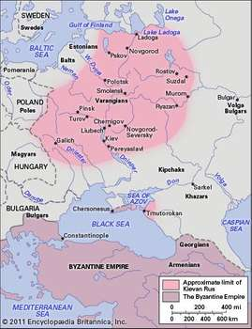
  - When: 988 C.E.
  - Where: Present day Ukraine and Western Russia
  - Main links were with Scandinavia and Byzantium
- How and why does it unify
  - Prince Vladimir of Kiev decided that a religion could unify the people
  - Converted many people to Eastern Orthodox Christianity
  - Eventually became their ruler, expanded the empire
- Political Factors
  - Interactions with the larger world lead to affiliation with the orthodox faith
  - Borrowed off of the nearby empires, like Byzantines, going as far to claim they were the “third rome”
- Religious Factors
  - Leader thought religion could unify his peoples
  - Similar religion made peoples feel welcomed and together
  - Peoples followed the rulers into the church, specifically the eastern orthodox faith
- Economic Factors
  - Traded with many nations, pivotal location geography wise for trading
  - The development of Kievan Rus was stimulated by trade

