CIVIL RIGHTS DBQ

The Civil Rights Movement is understood as the collected efforts of many different groups and individuals struggling to achieve justice and equal treatment for all Americans. Several events shaped the time period, particularly those that either showed the extent of injustice and unfair or violent treatment, as well as those that took direct action against injustice. Additionally, significant events were those where Civil Rights leaders could celebrate a concrete victory, such as a court decision or a change in law. Moreover, the organizing principles and philosophies of the movement changed as different leaders and organizations sought different outcomes through different means. Taken together, the documents below are illustrations of some of the major events from the Civil Rights movement, but should not limit your discussion.
From the 1950s to 1970s leaders of the Civil Rights movement used various methods to affect change. Analyze the types of resistance and the extent to which the methods successfully advanced the movement.

DOCUMENT 1: The Fifteenth Amendment to the US Constitution, 1870
- What legal right is the Fifteenth Amendment meant to protect and for what group of people?
Section 1. The right of citizens of the United States to vote shall not be denied or abridged by the United States or by any State on account of race, color, or previous condition of servitude.

Section 2. The Congress shall have power to enforce this article by appropriate legislation

DOCUMENT 2: Voter Registration Rates in Selected Southern States, 1965
State | Percentage of Voting Age African-Americans Registered to Vote | Percentage of Voting Age Whites registered to vote
Alabama | 19.3% | 69.2%
Georgia | 27.4% | 62.6%
Louisiana | 31.6% | 80.5%
Mississippi | 6.7% | 69.9%

- According to the chart, what inference can be made about barriers to voting for African Americans in the southern states?

DOCUMENT 3: George Wallace’s 1963 Inaugural Address as Governor of Alabama
- According to this document, what is one of George Wallace’s intentions as Alabama governor?
“… Today I have stood, where once Jefferson Davis stood, and took an oath to my people. It is very appropriate then that from this Cradle of the Confederacy, this very Heart of the Great Anglo-Saxon Southland, that today we sound the drum for freedom as have our generations of forebears before us done, time and time again through history. Let us rise to the call of freedom-loving blood that is in us and send our answer to the tyranny that clanks its chains upon the South. In the name of the greatest people that have ever trod this earth, I draw the line in the dust and toss the gauntlet before the feet of tyranny… and I say… segregation today…. Segregation tomorrow… segregation forever….”

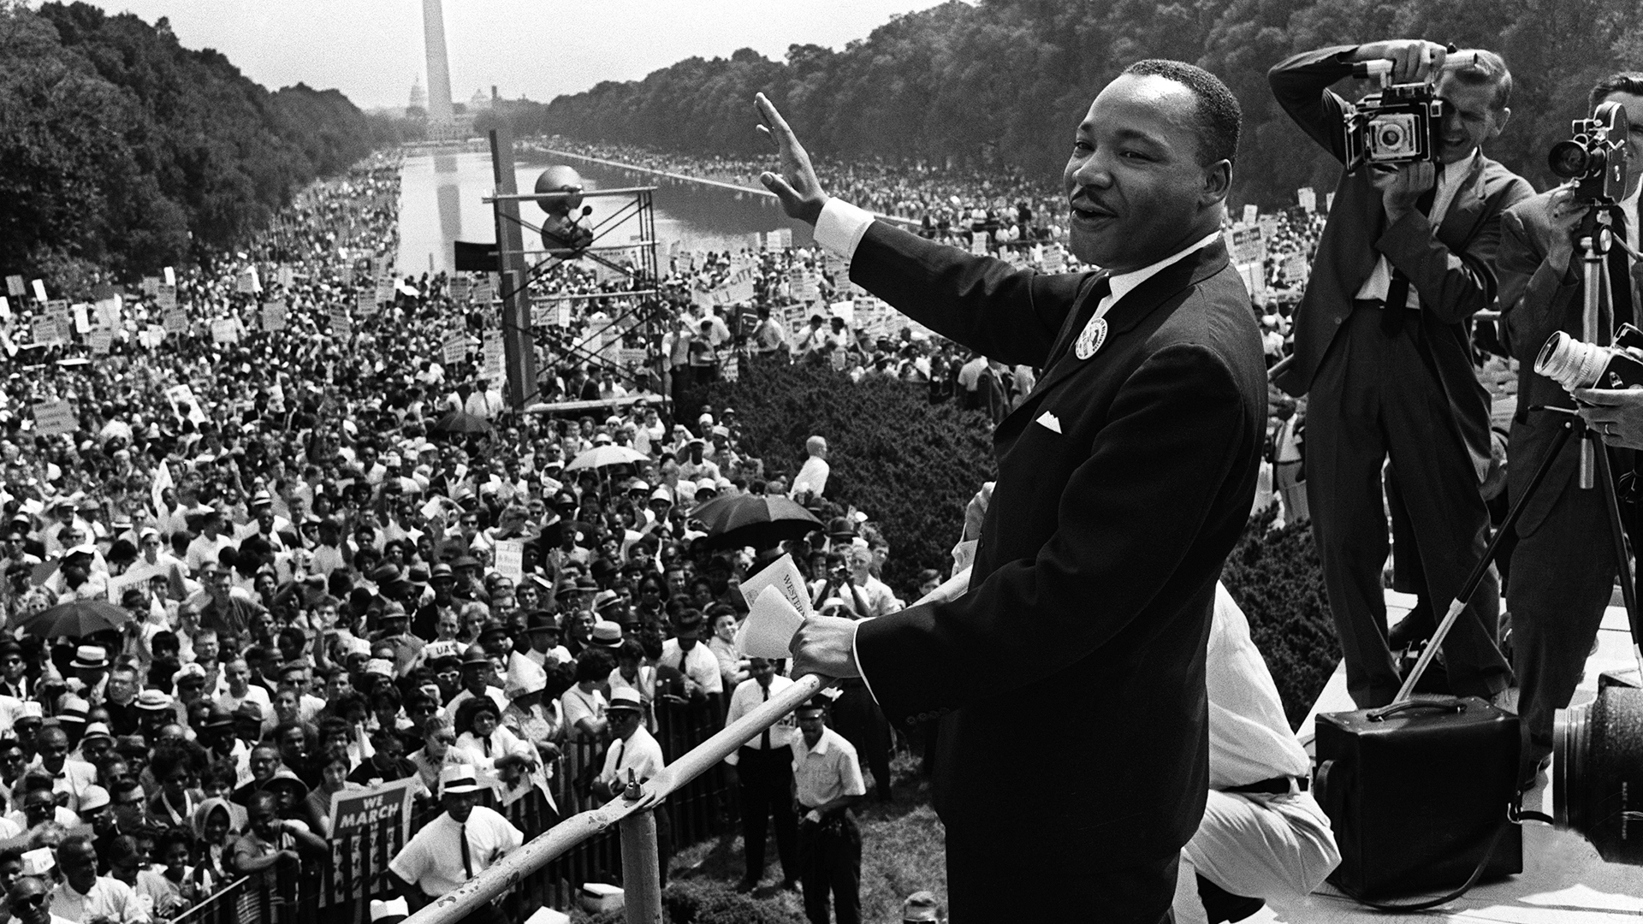
DOCUMENT 4: March on Washington, August 28, 1963

The March on Washington for Jobs and Freedom was primarily organized by Martin Luther King, Jr (MLK) representing the SCLC, John Lewis from SNCC and James Farmer of CORE, and was attended by over 250,000 people from across the country. Marchers and organizers demonstrated support for the passage of civil rights legislation, the elimination of racial segregation, jobs, equal opportunity in hiring and a meaningful minimum wage.

- What was the purpose of the March on Washington?

DOCUMENT 5: Voting Record in US Congress on the 1964 Civil Rights Act

 |  | Yes | No
Democrats | North | 145 (House)  46 (Senate) | 9 (House)  1 (Senate)
Democrats | South | 7 (House)  1 (Senate) | 87 (House)  21 (Senate)
Republicans | North | 138 (House)  27 (Senate) | 24 (House)  5 (Senate)
Republicans | South | 0 (House)  0 (Senate) | 10 (House)  1 (Senate)

- Which was a more accurate predictor for voting on the Civil Rights Act: political party (Democrat or Republican) or geographical location (North, South)? What does that show about the difference in political opinions nationally?

DOCUMENT 6: U.S. Congress, Civil Rights Act, federal law, 1964.

Civil Rights Act of 1964: Long Title: To enforce the constitutional right to vote, to confer jurisdiction upon the district courts of the United States to provide relief against discrimination in public accommodations, to authorize the Attorney General to institute suits to protect constitutional rights in public facilities and public education, to extend the Commission on Civil Rights, to prevent discrimination in federally assisted programs, to establish a Commission on Equal Employment Opportunity, and for other purposes.

. . . All persons shall be entitled to the full and equal enjoyment of the goods, services, facilities, and privileges, advantages, and accommodations of any place of public accommodation, as defined in this section, without discrimination or segregation on the ground of race, color, religion, or national origin.
. . . Whenever the Attorney General has reasonable cause to believe that any person or group of persons is engaged in a pattern or practice of resistance to the full enjoyment of any of the rights secured by this title, and that the pattern or practice is of such a nature and is intended to deny the full exercise of the rights herein described, the Attorney General may bring a civil action in the appropriate district court of the United States by filing with it a complaint . . . requesting such preventive relief, including an application for a permanent or temporary injunction, restraining order or other order against the person or persons responsible for such pattern or practice, as he deems necessary to insure the full enjoyment of the rights herein described.

- According to Document 6, what are two major legal changes made by the Civil Rights Act?

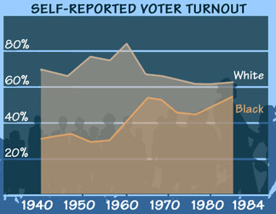
DOCUMENT 7: Voter Turnout from 1940 to 1983

- Explain what the graph depicts (shows). What caused a dramatic increase in the number of black voters around 1965?

DOCUMENT 8: Brown v. Board Decision, majority opinion
To separate [minority students] from others of similar age and qualifications solely because of their race generates a feeling of inferiority as to their status in the community that may affect their hearts and minds in a way unlikely ever to be undone.

We conclude that, in the field of public education, the doctrine of "separate but equal" has no place. Separate educational facilities are inherently unequal.
-Chief Justice Earl Warren, 1954

- According to the document, what legal precedent was established by the Brown v. Board decision?

DOCUMENT 9: Ella Baker, Student Nonviolent Coordinating Committee founding statement, 1960

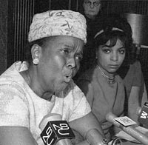
Student Nonviolent Coordinating Committee Founding Statement
We affirm the philosophical or religious ideal of nonviolence as the foundation of our purpose, the presupposition of our belief, and the manner of our action.
Nonviolence, as it grows from the Judeo-Christian tradition, seeks a social order of justice permeated by love. Integration of human endeavor represents the crucial first step towards such a society.
Through nonviolence, courage displaces fear. Love transcends hate. Acceptance dissipates prejudice; hope ends despair. Faith reconciles doubt. Peace dominates war. Mutual regards cancel enmity. Justice for all overthrows injustice. The redemptive community supersedes immoral social systems.

- According to the document, what does the Student Nonviolent Coordinating Committee (SNCC) believe about the practice of nonviolence?

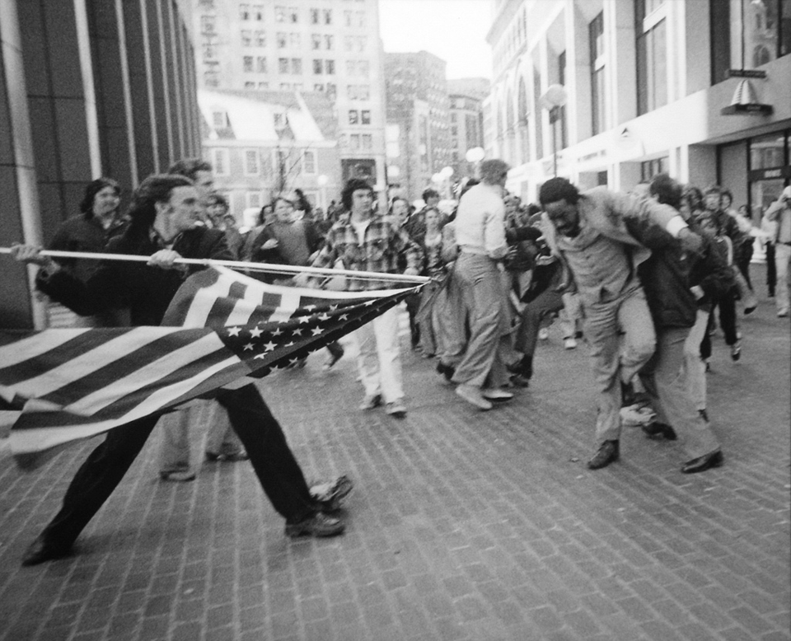
DOCUMENT 10: 1976, Boston City Hall, Stanley Forman Photograph

The photograph depicts a white teenager, Joseph Rakes, about to assault black lawyer and civil-rights activist Ted Landsmark with a flagpole bearing the American flag. It was taken in Boston on April 5, 1976, during a protest against court-ordered desegregation busing.
Courtesy of www.stanleyformanphotos.com

- What does this photograph indicate about the reactions to busing for school integration in Boston?

DOCUMENT 11: “Nonviolence and Racial Justice,” by Martin Luther King, Jr., 1957
Hence the basic question which confronts the world’s oppressed is: How is the struggle against the forces of injustice to be waged? There are two possible answers. One is resort to the all too prevalent [common] method of physical violence and corroding hatred….[Yet,] violence solves no social problems; it merely creates new and more complicated ones… If the American Negro and other victims of oppression [give in to] the temptation of using violence in the struggle for justice, unborn generations will live in a desolate night of bitterness, and their chief legacy will be an endless reign of chaos. The alternative to violence is non-violent resistance. This method was made famous in our generation by Mohandas K. Gandhi, who used it to free India from the domination of the British empire. Five points can be made concerning nonviolence as a method in bringing about better racial conditions.
1) First, this is not a method for cowards; it does resist.; [this] method is passive or non-aggressive in the sense that he is not physically aggressive toward his opponent. But his mind and emotions are always active, constantly seeking to persuade the opponent that he is mistaken
2) A second point is that non-violent resistance does not seek to defeat or humiliate the opponent, but to win his friendship and understanding… The aftermath of non-violence is the creation of the beloved community, while the aftermath of violence is tragic bitterness.
3) A third characteristic of this method is that the attack is directed against forces of evil rather than against persons who are caught in those forces. It is evil we are seeking to defeat, not the persons victimized by evil.
4) At the center of non-violence stands the principle of love. To retaliate with hate and bitterness would do nothing but intensify [make worse] the hate in the world. Along the way of life, someone must have sense enough and morality enough to cut off the chain of hate… Here we rise to the position of loving the person who does the evil deed while hating the deed he does.
5) Finally, the method of non-violence is based on the conviction that the universe is on the side of justice. This belief that God is on the side of truth and justice comes down to us from the long tradition of our Christian faith….So in Montgomery we can walk and never get weary, because we know that there will be a great camp meeting in the promised land of freedom and justice.

- Identify and evaluate two of the reasons that King gives for why nonviolent resistance is his preferred method of taking action.

DOCUMENT 12: Black Panther Party Platform, 1966
1. We want freedom. We want power to determine the destiny of our Black Community.
2. We want full employment for our people.
3. We want an end to the robbery by the white man of our Black Community.
4. We want decent housing, fit for shelter of human beings.
5. We want education for our people that exposes the true nature of this decadent American society. We want education that teaches us our true history and our role in the present-day society.
6. We want all black men to be exempt from military service.
7. We want an immediate end to police brutality and murder of black people.
8. We want freedom for all black men held in federal, state, county and city prisons and jails.
9. We want all black people when brought to trial to be tried in court by a jury of their peer group or people from their black communities, as defined by the Constitution of the United States.
10. We want land, bread, housing, education, clothing, justice and peace. [Black Panther Party]

- Based on the document, summarize the goals of the Black Panther Party in 1966.

DOCUMENT 13: David Fankhauser’s account of events along the Freedom Ride, 1961

On May 21, 1961, the surviving contingent of Riders took a bus from Birmingham to Montgomery, Alabama, protected by a contingent of the Alabama State Highway Patrol. However, when they reached the Montgomery city limits, the Highway Patrol abandoned them. At the bus station, a large white mob was waiting with baseball bats and iron pipes. The local police allowed them to viciously beat the Freedom Riders uninterrupted. Again, white Freedom Riders, branded "Nigger-Lovers," were singled out for particularly brutal beatings. There is a famous picture of Jim Zwerg with blood running all down his suit. Justice Department official Seigenthaler was beaten and left unconscious lying in the street. Ambulances, manned by white attendants, refused to take the wounded to the hospital. Brave local blacks finally rescued them. A number of the Freedom Riders were hospitalized.

- What did David Fanhkauser and other Freedom Riders experience in Montgomery, Alabama?

DOCUMENT 14a and 14b: Malcolm X and Stokely Carmichael Statements

“This is the twenty-seventh time I have been arrested – and I ain’t going to jail no more! We been saying freedom for six years – and we ain’t got nothin’. What we’re gonna start saying now is Black Power.”
- Stokely Carmichael
Rally in Greenwood, Mississippi, 1966

“It is criminal to teach a man not to defend himself when he is the constant victim of brutal attacks. It is legal and lawful to own a shotgun or rifle. We believe in obeying the law. The time has come for the American Negro to fight back in self-defense whenever and wherever his is being unjustly and unlawfully attacked.”
- Malcolm X
Press Conference, New York City 1964

- What is the comparison that Carmichael and Malcolm X draw between Black Power and Self-Defense and nonviolence?

