As prehistoric settlers migrated and settled across the vast expanse of the Americas, they developed quite different and increasingly complex societies by adapting to and transforming their diverse environments.

Use the following images and terms defend this statement.
Maize/corn Inca Culture Aztec Culture Great Plain/Great Basin Culture Iroquois(Atlantic Seaboard Culture)

Three-sister Farming Hunter Gatherer Societies Mixed Agricultural Societies Nation States
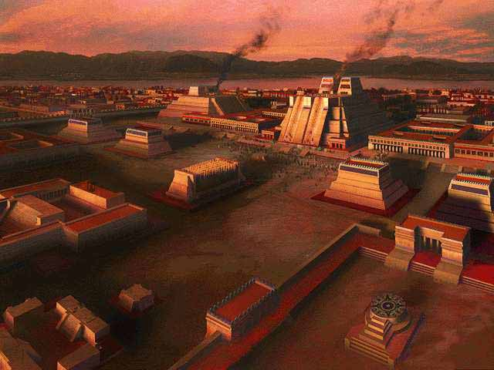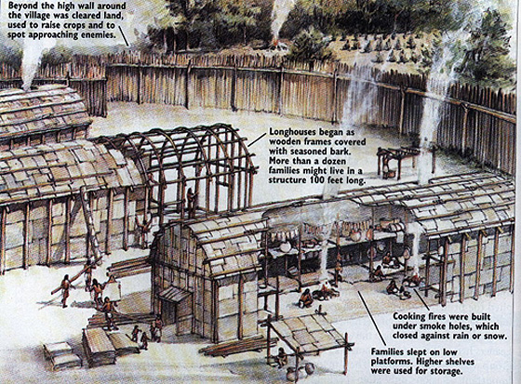
Aztec City Iroquois Longhouse 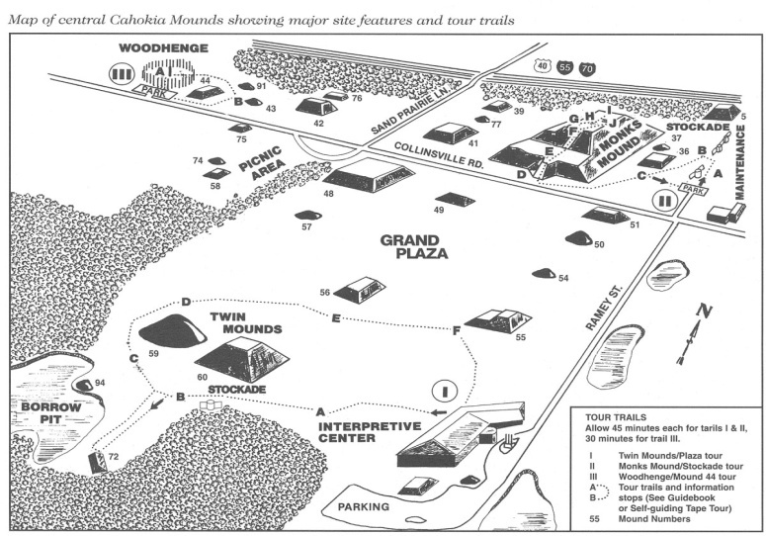 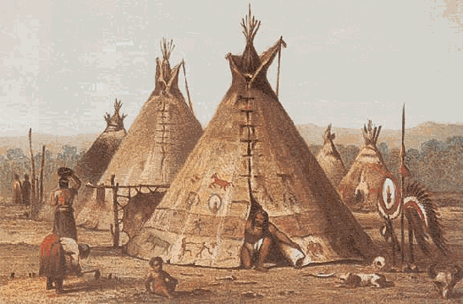
Modern Archaeological Map of Cahokia Settlement (Missouri River) Image of Kiowa Indians (current day Oklahoma)

Create at five arguments to support this thesis:

1.
2.
3.
4.
5.

